27th June 2012
To All Members of the Parish Council

You are summoned to attend a meeting of the Lympstone Parish Council, at 7.30 on Monday 2nd July 2012 in the Village Hall. The business to be transacted is set out below. Members of the Public are cordially invited to attend and to speak in the open session. 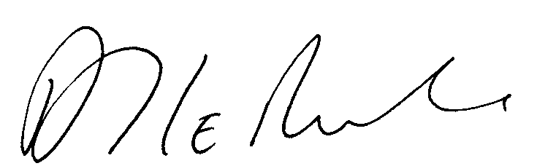

A J Le Riche, Clerk to the Parish Council

PUBLIC SESSION
At this point the public will be invited to raise issues of concern in the Parish

AGENDA
1 Apologies

2 Declarations of Interest

3 CTC-RM Young Officers Village Exercise
Captain Whiteman will address the Parish Council upon a request for an exercise to be held from 26th – 28th September 2012.

3 Minutes – To confirm the minutes of the meeting held on 18th June 2012 - attached

4 Planning Decisions, if any

5 Neighbourhood Planning update

6 Report by the Police

7 Report by the District Councillors

8 Chairman’s report

9 A New Code of Conduct - The Localism Act 2011, requires the Council to adopt a new Code of Conduct from 1 July 2012. It is recommended that either the NALC Code or EDDC Code is adopted.
The attached code has been adopted from the EDDC Code and is recommended for adoption.
Members will be required to complete new register of Interests by 28th July 2012. A form for this is enclosed with your agenda.

10 Finance
a) Payments authorised – list attached

11 Toddler Play Area
The Parish Council’s application for funding in the sum of £10,202 for providing a new surface for the toddler play area and painting the fence and equipment has been approved by the MoD Community Covenant Panel.
The prices for the work will need to be updated. It is already know that these is a shortfall of £500 on the cost of painting. The Chairman and Clerk will investigate possible sources of funding for this.

12 Business items

Affordable Housing | Cllr Bailey
Amenities | Cllr Acca / Cllr Mrs Beatty
Burial Ground | Cllr Bailey
Communications | Cllr Young
Environment | Cllr Eastley
Major Travel including the Cycle Way | Cllr Bailey
Planning applications | Cllr Longhurst
Neighbourhood Plan | Cllr Longhurst
Twinning | Cllr Mrs Scott
Youth Club | Cllr Mrs Beatty

13 Action Sheet – attached

14 Matters raised by Councillors. - (These are not normally discussed in depth but investigated and considered at the next meeting.)

15 Items for the next meeting

16 Items for information, Copies will be available at the meeting:

17 Report by County Councillor on matters relating to the Parish.

