PLEASE NOTE THE VENUE FOR THIS MEETING

1st October 2013
To All Members of the Parish Council

You are summoned to attend a meeting of the Lympstone Parish Council, at 7.30 on Monday 7th October 2013 in the Methodist Church Hall. The business to be transacted is set out below. Members of the Public are cordially invited to attend and to speak in the open session. 

A J Le Riche, Clerk to the Parish Council

PUBLIC SESSION
At this point the public will be invited to raise issues of concern in the Parish

AGENDA
1 Apologies

2 Declarations of Interest

3 Minutes – To confirm the minutes of the meeting held on 16th September, 2013 - attached

4 Planning Applications
Ref 13/2025/MOUT Outline application (appearance, landscaping and scale reserved) for the construction of 33 dwellings and associated open space, balancing pond, footpaths and structural planting Land North and West of Courtlands Cross, Courtlands Lane, Exmouth.

5 Other Planning matters
Proposals for Upper Lovering Farm, north of Dinan Way. Developers have invited the Parish Council to attend an exhibition of the proposals from 3.30pm -4.30pm on Thursday 10th October at the, School Hall on the Upper School site of Brixington Primary School

6 Neighbourhood Planning update

7 Report by the Police

8 Report by the District Councillors

9 Chairman’s report

10 Seagull Summit details attached
East Devon District Council are inviting representatives of all coastal businesses and representatives of coastal Town and Parish Councils to a Seagull Summit from 6pm to 8.30pm on Thursday 31 October at EDDC Offices, Knowle, Station Road, Sidmouth.

12 Tackling Rural Isolation Conference Friday 1st November 2013, Cullompton

13 Dog Bins
CTC – RM have asked if the Parish Council will consider installing dog bins on the Exe Estuary Trail outside the railway entrance to the camp and on Red Barn Lane. Both the locations are on Woodbury PC area but the Parish Council is requested to consider this as a goodwill gesture to CTC RM.

14 Applications for financial assistance – details are attached.

15 Finance
a) Payments authorised – list to follow
b) Financial summary – to follow
c) Budget report attached – to follow

16 Matters raised by Councillors. - (These are not normally discussed in depth but investigated and considered at the next meeting.)

17 Items for information, Copies will be available at the meeting:

18 Report by County Councillor on matters relating to the Parish.

19 Exclusion of the press and public

20 Neighbourhood Plan – Planning Brief for the Lympstone Nurseries site
To consider a proposal for preparation of this Brief.

MINUTES OF A MEETING OF LYMPSTONE PARISH COUNCIL HELD AT 7.30PM ON MONDAY 16th SEPTEMBER 2013 IN THE VILLAGE HALL.

PRESENT: | Councillors: | P Acca | R Eastley (Chairman)
 |  | J Bailey | R. Longhurst
 |  | Mrs D Beatty | Mrs K Rogers
 |  | C Carter Vice chairman, in the Chair | Mrs T Scott
 |  | Mrs J Clark

Apologies: Cllr D Atkins

Also Present: Capt. Simon Broomfield, District Councillor Ingham and 11 members of the public.

131 | Chairmanship  Cllr Eastley was present at the meeting but asked the Vice Chairman to take the chair for the meeting. This was accepted.
132 | CTC-RM Village Exercise  Capt. Broomfield informed the meeting that the exercise was planned to take place from 28th September to 1st October 2013 and would follow a similar pattern to previous exercises. There had been publicity in the Lympstone Herald and discussions with some Groups in the Parish.  Information signs would be placed on the Exe Estuary Trail and the main entrances to the Village. No objection has been forthcoming.  RESOLVED that the proposals for a Village Exercise be fully supported.
PUBLIC SESION
There were no comments from the Public at this stage of the meeting.

133 | Declarations of Interest  Cllr Mrs Scott declared a personal interest in Plan no 13/1926/27.
134 | Minutes  RESOLVED that the minutes of the meetings held on 2nd and 9th September 2013 be confirmed as a correct record and signed by the Chairman.
135 | Casual Vacancies  The remaining casual vacancy has been advertised.  One person was interested but was not able to attend the meeting due to a family tragedy.  RESOLVED: that the matter be deferred to the next meeting.
136 | Planning Applications  13/1985/FUL Construction of two storey extension and provision of Juliet balcony to existing north west elevation. The Hollow Pitt Farm, Exmouth Road – SUPPORT  13/1962 LBC demolition of coal bunker at Jonquil Cottage, The Strand. In view of the timing, Cllr Longhurst had informed EDDC that the Council had no objections to this application. This was supported.  13/1926/FUL & 1927 LBC, Demolition of outbuilding and part boundary wall, and construction of dwelling including formation of new vehicular access and provision of parking area. Oak Cottage, Church Road. The Council heard from Mr Cole of Briar Cottage regarding planning history of this site. He also reported difficulty in accessing the plans associated with this development. He asked the Council to object to the application on the following grounds:  1 The proposed building is out of line with the building line for this area.  2This application could set an unfortunate precedent for other properties in the immediate vicinity which would be detrimental to the character of the area.  3 There is reference to a family member working from the proposed property but no application for this use, the details of which are therefore unknown.  4 The development would create a hazardous traffic situation despite the comments of DCC.  Cllr Longhurst reminded the Council that Oak Cottage was a Grade II Listed Building, in a Conservation Area. The scale and mass of the proposed building was greater than that of the existing outbuildings and the proposal would affect the setting of the Listed Building. The proposal provides for two parking spaces but one of the existing spaces would be lost. Eight trees were noted on site but seven would lost by the development including a large Oak tree which appeared to be  healthy.  OBJECT on the following grounds: out of keeping with the area including the building line, materials and design, highways, out of keeping with the Local Plan, the draft Neighbourhood Plan and the Village Design Statement.  Cllr Mrs Scott took no part in the discussion and did not vote.
137 | Planning Decisions  13/1135/CPE Certificate of Lawfulness re use as a dwelling at Loxhill, Courtlands Lane. APPROVED  13/1234/FUL Demolition of garage and rear veranda and construction of home office and rear extension. Timber cladding to existing side extension and construction of decking. 2 Park View, Wotton Lane. APPROVED.
138 | Other planning matters  Possible development at Courtlands Lane /A376  The Council had received a pre-application consultation on a possible development on land at the junction of Courtlands Lane and the A376. The application had now been submitted and would be on the agenda for the next meeting.  Cllr Longhurst reminded the Council that he had taken a lead role in responding to the community's wish to oppose the previous application and asked the Council whether in view of this he would be construed as having a prior interest in this application and as such he should not take any part in consideration of the application.  The clerk advised that Cllr Longhurst had acted in accordance with his role as Planning Champion and was responding to the clearly and strongly expressed views of a very large proportion of the community. As such he should not be construed as having an interest in this matter.  RESOLVED: that it be recognised that Cllr Longhurst has no interest in any application for development of land in the Courtlands area and that he be requested and authorised to lead the Parish Council and the community, through the process of responding to this proposal.  Cllr Bailey declared an interest in this matter and did not take part in any discussion.  Cllr Longhurst had circulated an outline statement and suggested that the developer should be invited to the Council meeting to explain their proposals in more detail.  RESOLVED: 1 that SLP be invited to the next Council meeting to explain this proposal.  2 that Cllr Longhurst be authorised to take steps to raise public awareness of this application.  EDDC Local Plan follow up consultation  The Local Plan Inspector had asked EDDC to carry out a second consultation on the main changes to the draft Local Plan. Cllr Longhurst had directed Members to points of concern that directly affected the Parish.  Discussion focussed on the late inclusion in the draft Plan of a proposal for a new primary School on the Goodmore’s Farm site. This had been included in a DCC Strategy Plan and so had to be included in the Local Plan. The precise site had not yet been defined.  RESOLVED: 1 that Cllrs Longhurst and Mrs Clark be authorised to prepare and submit the Parish Council’s response to the latest consultation, this being circulated to other Councillors for comment beforehand.  2that the response be based on the previous comments to the draft local plan including and emphasising that only houses should be built on the Lympstone part of the Goodmore’s farm site.  3that support be given for the statement regarding the role of Neighbourhood Plans in the Local plan context.
139 | Neighbourhood Plan update.  There was to be an exhibition of the version of the Plan that had been approved by the Parish Council at the Village Hall on 20th & 21st September 2013.  A letter had been received from the PCC asking the Parish Council to address the need of extra parking for church events in the Neighbourhood Plan. As the letter had been received well after the closure of the Public Consultation phase, it could not be included in the revised Plan. The PCC would be advised of this and of the current ideas for The Nurseries site.  Cllr Bailey expressed concern that the views of a Village organisation were being ignored. It was pointed out that Cllr Bailey was a Member of the PCC and had been asked to seek their comments as part of the consultation phase.  At the last meeting, three Councillors had voted against the Neighbourhood Plan. Cllr Longhurst had asked them to give reasons for this for future guidance. He awaited responses.
140 | Grants  The Council received details of applications for financial assistance including recurring contributions to the CAB, Ring and Ride Service and Gulliford Joint Committee.  Cllr Carter declared and interest in the CAB and took no part in the discussion and did not vote.  Cllr Bailey declared an interest as a member of the PCC and the Ring and Ride scheme.  The other applications were from  LYPS – purchase of a Pinball Machine  PCC repairs to the Church clock  VHMC – Cycle racks and outdoor tables  A late application had been received from the Lympstone Players for repair and cleaning of the stage curtains at the Village Hall.  The meeting was reminded that Cllr Hughes had a community fund and wished to be part of the grant making process.  RESOLVED: that the recurring grants be paid.  2 that the remaining applications be deferred for consideration by Cllr Hughes.
141 | Sustainable Communities Act  The report of the Clerk was received reminding the Council that EDDC was taking part in the Sustainable Communities Act and was asking Parish Councils to submit proposals.  The Sustainable Communities Act aimed to divert power and funding from central government and passes it to councils and local people, giving them a new opportunity to improve their local communities.  The report suggested that the Council could consider whether it wishes to submit a proposal to change the process for traffic and other regulatory orders so that any Order which is only of local significance should not need to be advertised in the London Gazette. It was considered that this requirement was now well out of date and imposed an unnecessary cost on local action.  Cllr Hughes had fully supported this proposal.  RESOLVED: that the proposal be supported and submitted to EDDC.
142 | The East Devon AONB Draft Management Strategy 2014-19  This was now out for consultation.  RESOLVED: that no comment be made.
143 | Street naming  EDDC had received a request to register a name for 13 new properties to be built at Jackson Meadow. This development will require one new road name. The suggestion they have received from the developer is Summer Meadow. Royal Mail had no objections to Summer Meadow as there is nothing similar already in Lympstone or Exmouth.  The Parish Council is asked to consider this or suggest an alternative.  RESOLVED That The Chairman of the Jackson Meadow residents Association be invited to suggest a name and that this be offered to EDDC.
144 | Village entrance signs  A revised quote for 6 new signs has been received from SWH in the sum of £1,576.27 + VAT. The logo can be included.  RESOLVED: that the revised quote be accepted.
145 | Post Office Community Enterprise Fund  Post Office branches in England (excluding Crown branches) can now apply to receive up to £10,000 to support a new scheme or service for their local community. These could include:  Classes in key skills such as reading, languages or the Internet  Mentoring and advice service for local small businesses, or display space for local producers  Partnership with a local charity to provide a meeting space, notice board and other forms of support  A hub or meeting space for community groups involved in local issues, such as neighbourhood planning  The Postmaster has asked if the Parish Council have any suggestions for such a scheme.  RESOLVED: that it be suggested to the Postmaster that a scheme to replace all of the noticeboards under the railway bridge and to include a notice board for local business could be put forward.
146 | Business items  Affordable Housing nothing to report  Amenities Cllr Acca reported that the play equipment was being painted this week. The contractor had been refused access to water supplies by the VHMC.  Work had started on the new surface at the entrance to Cliff Field.  Volunteers from the sailing Club had asked for £25.00 to spend on bulbs for the beds at Meeting Lane. This was AGREED.  Burial Ground Cllr Bailey read a letter of thanks from Mrs Neeson for the works that had been carried out to protect and encourage the memorial Oak tree in the cemetery.  Environment Cllr Eastley had reminded Cllr Hughes of the need to clear the highway gullies at Pretty Corner.  Travel and Transport No report  Twinning No report  Village Hall Cllr Mrs Scott reported that the VHMC were now offering the Village hall as a wedding venue. There was a long lead time for weddings and this meant that the Village hall would not be available to local organisations. It also posed extra parking problems and confusion if there was also a wedding at the Church.  RESOLVED: that the VHMC be requested to give their long-term view of arrangements for weddings and the knock-on effect of these in the Village.  Youth Club Cllr Mrs Beatty reported that last week saw the first youth club sessions after the summer break. Usually on the first junior session back whilst school is still closed attendance is very poor so we were pleasantly surprised to have 27 juniors in attendance. The senior session saw 23 members attend the highest number for some time.  Last Friday saw 28 senior members attending and the hall was decorated with good luck banners by Lauren and Louisa to give our eldest member Connor Breslan a send-off before he joins the army on Tuesday. A cake was also presented to Connor with his picture on and shared amongst the members. The evening finished with most of the members dancing to some real party music. All in all the evening was amazing and it made everyone feel very proud to see so many members having such a great time.  The Youth Club had applied for grants from the Gibbins Trust and the Norman Trust.  Mr Mingo had asked if a bolt could be put on the games room side of the new door to prevent the doors being pulled open from the main hall and thus prevent unauthorised access.  The Clerk also suggested that the front of the stage could be repaired at the same time.  RESOLVED: that the work be put in hand. Cllr Acca declared an interest in this matter and took no part in the discussion.
147 | Matters raised by other Councillors  Cllr Longhurst reported that there were to be major cuts to public transport subsidies and this would affect the bus services serving the Parish. RESOLVED: that this be included on the agenda for the second meeting in October  Cllr Longhurst asked if EDDC could be chased about their offer to hand over the Underhill car park.  Cllr Acca reported that there had been sewage flowing down Burgmanns Hill last week.  Cllr Carter reported a telephone call about this as a possible water leak.  Cllr Mrs Scott reported that the bin at The Rag was being used to dispose of recyclable household waste including food waste. It was AGREED that an article should go in the Herald about this.  Mrs Rogers reported that she was meeting Officers from EDDC to discuss the problems of parking in Glebe Close.

The meeting finished at 9.40pm

Chairman

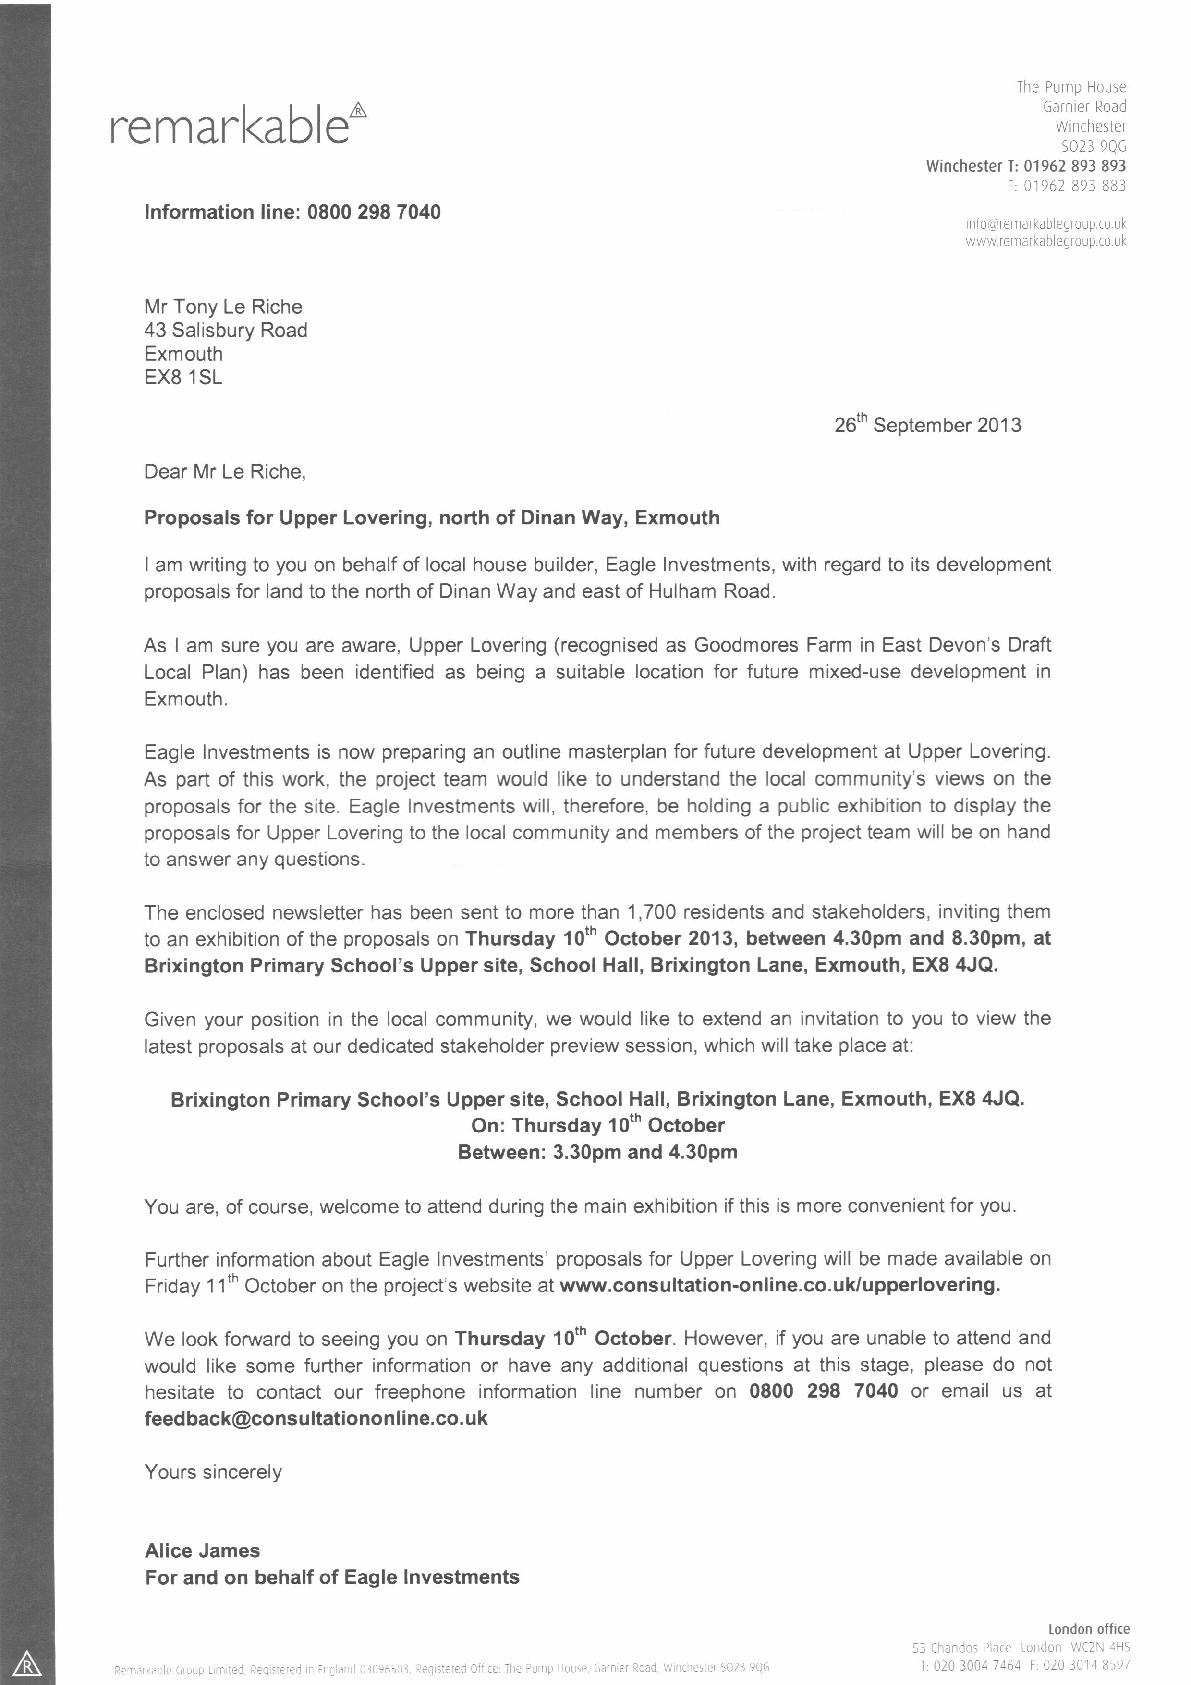

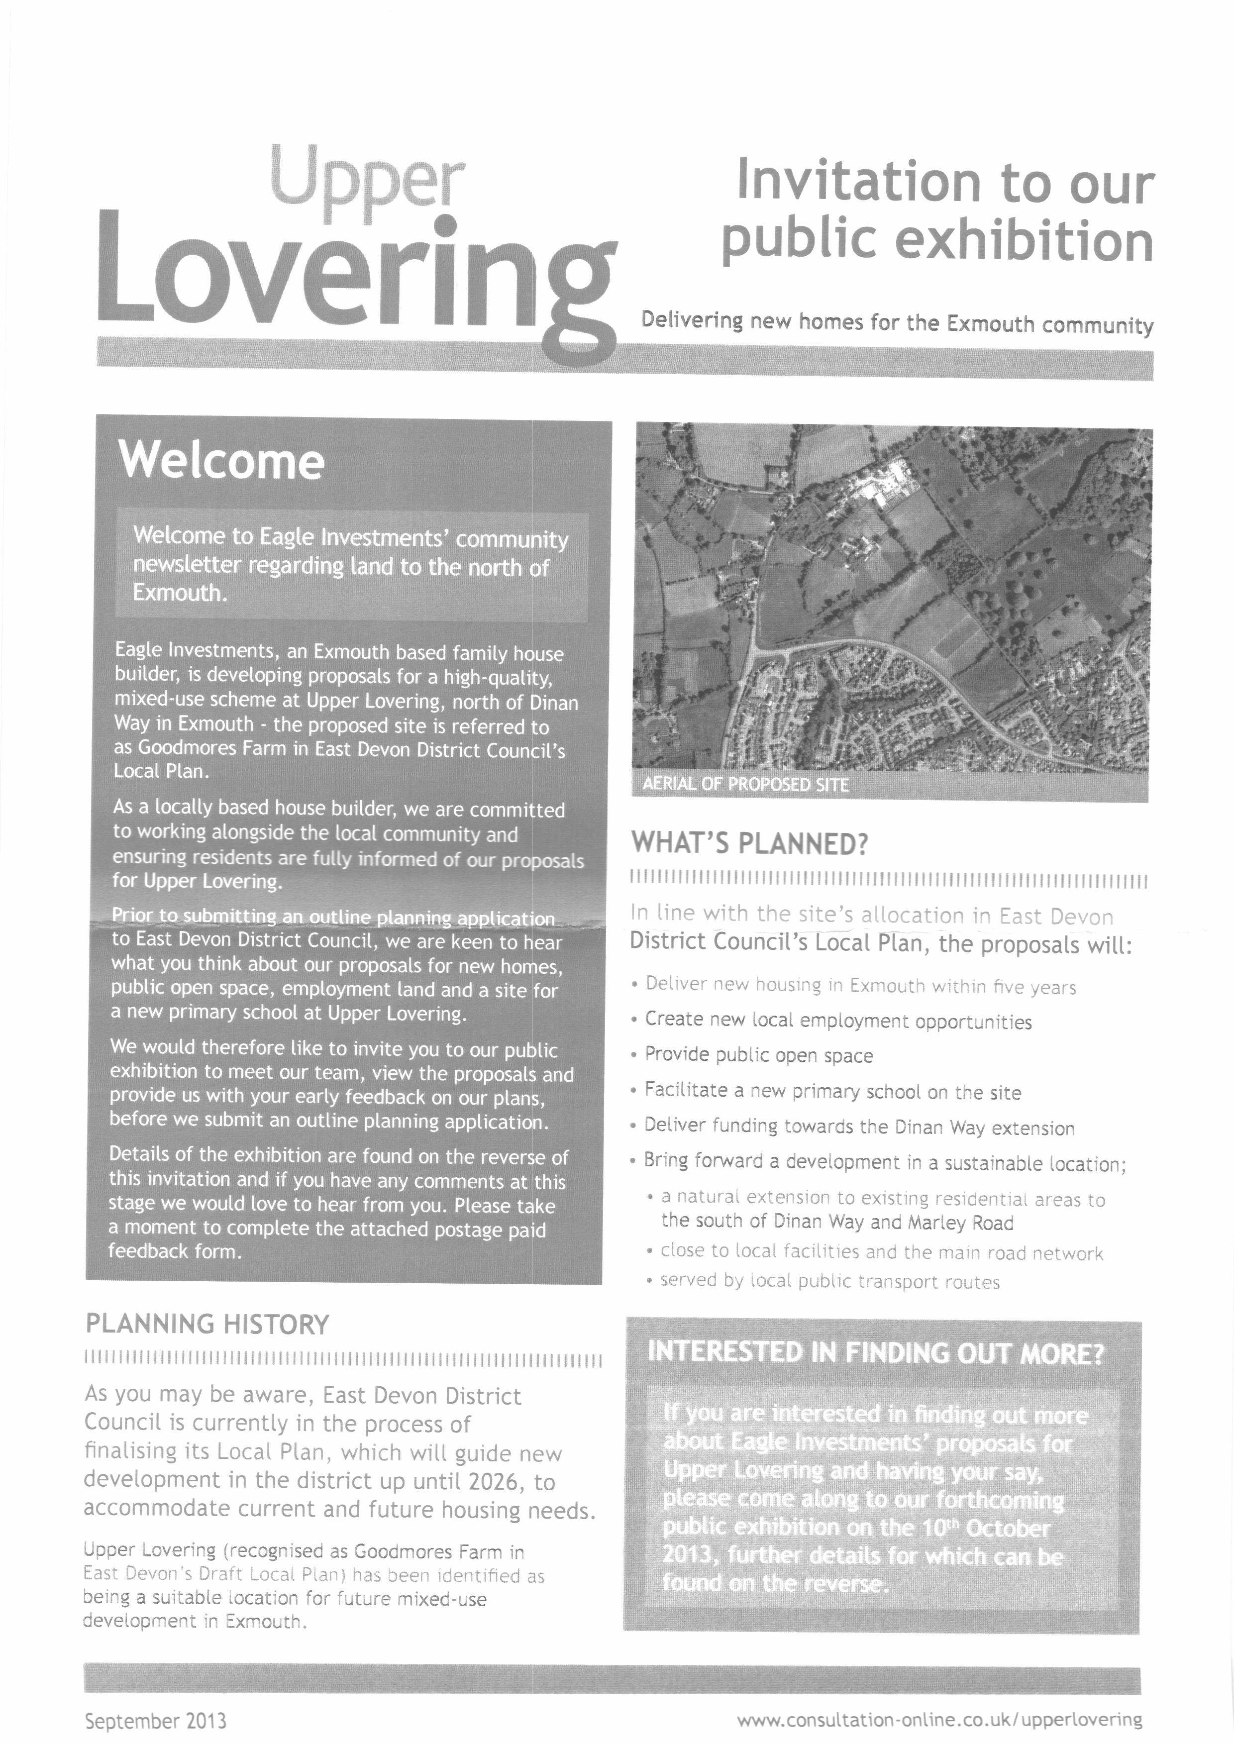
Seagull Summit

East Devon District Council are inviting representatives of all coastal businesses and representatives of coastal Town and Parish Councils to our free Seagull Summit on Thursday 31 October. It will be from 6pm to 8.30pm at EDDC Offices, Knowle, Station Road, Sidmouth, EX10 8HL.

Please help us spread the word and send this invite onto all your relevant contacts, particularly in the business community.

We are organising this event as seagulls have been quite a problem and of particular concern to local businesses this year. We want to work together with local businesses with the intention of gaining better understanding of actions that can be taken to reduce the problem.

There will be advice for you on:
- Seagull lifestyles
- Waste and pest control for food businesses
- What residents and businesses can do – proofing and control
- Bins and commercial waste
- Pest control services and successes
- What Seaton Town Council are already doing
- The legal situation

This is likely to be a one-off event, come along to find out more.

To book a place, please e-mail jbuckley@eastdevon.gov.uk by 23 October, please include:
- Your name
- The name of the Town or Parish Council or business you represent
- How many places you would like to book
- Your location in the district

Further information will be sent out closer to the event.

Regards

Miss Jamie Buckley

Community Engagement and Funding Officer
East Devon District Council
(01395) 517569
jbuckley@eastdevon.gov.uk
Item 12

Tackling Rural Isolation Conference

Friday 1st November 2013 – 10am – 3pm

Cullompton Community Centre, Pye Corner, Cullompton, EX15 1JX

Outline Programme for the day

09.45 Arrival/Registration/Coffee/ Stands
10.10 Welcome, Housekeeping, Outline of the day.
10.30 Session one – Transport
11.00 A number of short service presentations
11.30 Tea/Coffee/Stands/Networking
12.00 Session two – Information Technology
12.30 A number of short service presentations
13.00 Lunch/Tea/Coffee/Stands/Networking
13.45 Session three – Local Services
14.30 Summary / Discussion
15.00 Close
£5 including refreshments and buffet lunch

Spaces will be limited – please book now to help us with planning and avoid disappointment.

Parish Council grants

Each year the Parish Council includes in its budget a sum for providing financial assistance to local groups. This can be in the form of a cash grant or the purchase of goods or services. If these are then given to the organisation, the Parish Council can reclaim any VAT. The availability of grants has been advertised on the notice boards and on the website.

This year the sum of £ 2,600 has been included in the budget.

The following applications have been agreed:

1st Lympstone Brownie Pack | grant for celebrations | £147.00
ED CAB | Running costs | £235.44
Ring & Ride | Annual contribution | £250.00
Gulliford Joint Committee | Annual contribution | £200.00
 |  | £832.44

Applications to be considered
Poppy Appeal | Chairman’s Wreath | £25.00
LYPS | Purchase of pinball machine | £399.17 +VAT
Lympstone PCC | Cost of servicing repairing and repainting the church clock | Total cost = £1614.00 + VAT
Lympstone VHMC | Cycle racks | £250.00 + VAT
Lympstone VHMC | Outdoor folding tables @ £35 each | 10 =£350.00  20 = or £700.00
Lympstone Players | Cleaning and repair of stage curtains | Over £400.00
Lympstone Pre-school | Pay for an Apprentice £93 X 44 weeks | £4,092.00
LYPS all inc VAT | bouncy castle obstacle course | 2,352.00
 | air hockey table | 579.00
 | gladiator inflatable | 1,944.99
 | table tennis | 339.95
 | sumo suits | Unknown

The Parish Council is requested to determine these applications and suggest any others.

Lympstone Parish Council
Finance Reports for 7th October 2013
1Payments for approval
1919 |  | P Acca Doors in the Youth Club (paid) | 1,869.60
1920 |  | EDF Energy - lights in Candy's Field and toilets | 59.34
1921 |  | Optima Graphics Herald, NP & Courtlands printing | 521.00
1922 |  | Gardencare (Marsh Green) - contract& works in the Cemetery | 424.20
1923 |  | East Devon CAB grant | 250.00
1924 |  | Exmouth Community Transport Scheme grant | 250.00
1925 |  | Scottish Power - Youth Club electricity | 250.60
1926 |  | Peter Tate electrical repairs to toilets | 48.00
1927 |  | Hy-Tex UK Ltd Plastic tiles etc fro Cliff Field | 1,606.20
1928 |  | Mrs C Edworthy wages September 2013 | 185.70
1929 |  | AJ Le Riche salary for September | 667.26
1930 |  | HMRC - Tax / NI September | 127.32
1931 |  | G Brister painting toddler play equipment | 500.00
 |  |  | 6,759.22
2 Financial Summary
 |  | Current Account
 |  | Opening balance at 1st April 2013 | 25,731.63
 |  | Receipts | 34,721.18
 |  | Total receipts | 60,452.81
 |  | Transfer from dep ac
 |  | Total paid in to current ac | 60,452.81
 |  | less, Payments | 23,806.61
 |  | Net balance | 36,646.20
 |  | Receipts not on statement: | -1,242.50
 |  | Unpresented cheques | 5,726.40
 |  | Balance per Bank Statement 23rd August 2013 | 41,130.10
 |  | Deposit Account
 |  | Balance at 1st April 2013 | 159.81
 |  | Interest to 1st September 2013 | 0.06
 |  | Transfer to current ac | 0.00
 |  | Total | 159.87

Lympstone Parish Council 7th October 2013
 | Budget Monitoring 2012 - 13
 | Expenditure
Code | Item | Budget | Spent | Balance
10 | VAT |  | 1,239.64
100 | S137 | 1,000.00 | 147.00 | 853.00
101 | Other Grants | 1,600.00 | 200.00 | 1,400.00
201 | Clerk's Salary | 8,500.00 | 4,243.95 | 4,256.05
203 | Office expenses | 1,000.00 | 503.05 | 496.95
208 | Village Hall Hire | 400.00 | 394.88 | 5.12
209 | Miscellaneous | 50.00 | 3,062.98 | -3,012.98
301 | Chairman's Allowance | 135.00 | 135.00 | 0.00
302 | Subs | 525.00 | 360.88 | 164.12
307 | Courses, Travel etc | 150.00 | 0.00 | 150.00
308 | Insurance, Audit, Elections | 3,000.00 | 1,907.75 | 1,092.25
313 | Miscellaneous | 50.00 | 30.00 | 20.00
400 | Herald Printing | 3,000.00 | 1,340.00 | 1,660.00
602 | Grass Cut 2* | 3,300.00 | 1,946.50 | 1,353.50
605 | Other Maintenance | 500.00 | 543.54 | -43.54
608 | General tree work | 300.00 | 499.00 | -199.00
612 | Bin emptying | 100.00 | 0.00 | 100.00
616 | Benches - Maintenance | 100.00 | 0.00 | 100.00
618 | Notice Boards - Maintenance | 100.00 | 0.00 | 100.00
633 | Play Equipment Mtce | 200.00 | 433.00 | -233.00
640 | Lighting in Candy's field | 400.00 | 133.01 | 266.99
701 | Wages | 2,200.00 | 1,133.07 | 1,066.93
702 | Consumables, rates, elec | 200.00 | 107.90 | 92.10
703 | Rates, Utlities | 2,200.00 | 225.76 | 1,974.24
706 | Repairs | 250.00 | 0.00 | 250.00
800 | Burial Ground | 500.00 | 0.00 | 500.00
850 | Communications | 500.00 | 0.00 | 500.00
900 | Planning* | 1,000.00 | 1,507.71 | -507.71
1000 | Travel & Transport | 0.00 | 0.00 | 0.00
1101 | Building Maintenance* | 1,000.00 | 55.00 | 945.00
1102 | Gas Elec* | 500.00 | 718.45 | -218.45
1103 | YC rates | 500.00 | 1,172.96 | -672.96
1200 | Environment | 200.00 | 0.00 | 200.00
1300 | Website etc | 400.00 | 265.58 | 134.42
1400 | Snow Clearance | 500.00 | 0.00 | 500.00
1500 | Localism Bill | 0.00 | 0.00 | 0.00
1600 | Youth Club - New works | 0.00 | 0.00 | 0.00
1700 | VH Awning | 1,500.00 | 1,500.00 | 0.00
Ext | External funding | 500.00 | 0.00 | 500.00
 | Dep Ac | 0.00 | 0.00 | 0.00
 | Sub-Total | 36,360.00 | 23,806.61 | 13,793.03
 | VAT |  | 0.00
 | Total |  | 23,806.61
LYMPSTONE PARISH COUNCIL
Receipts - Budget Performance
 |  | Budget | Actual | Balance
 | Precept | 37,555.00 | 18,777.50 | -18,777.50
 | DCC re Candys Field | 400.00 | 300.00 | -100.00
 | Herald Adverts | 3,000.00 | 2,320.30 | -679.70
 | Burial fees | 1,000.00 | 380.00 | -620.00
 | Lympstone FC re Candy's Field | 50.00 | 0.00 | -50.00
 | Flower beds | 250.00 | 50.00 | -200.00
 | Western power re Wayleaves | 6.38 | 6.38 | 0.00
 | Miscellaneous | 0.00 | 0.00 | 0.00
 | Website | 350.00 | 0.00 | -350.00
 | VAT Refund (part year). | 150.00 | 0.00 | -150.00
 | Sub total | 42,761.38 | 21,834.18 | -20,927.20
 | Grant for car park | 0.00 | 3,310.00 | 3,310.00
 | External funding | 0.00 | 0.00 | 0.00
 | VHMC | 0.00 | 0.00 | 0.00
 | MoD Community Covenant | 0.00 | 0.00 | 0.00
 | DCC payment in error | 0.00 | 2,825.00 | 2,825.00
 | NP Funding | 0.00 | 6,752.00 | 6,752.00
 | Sub total | 0.00 | 12,887.00 | 3,310.00
 | Total | 42,761.38 | 34,721.18 | -17,617.20

