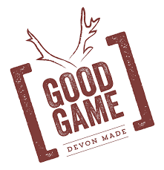

Good Game Set to Launch Their First Pub in Lympstone Village

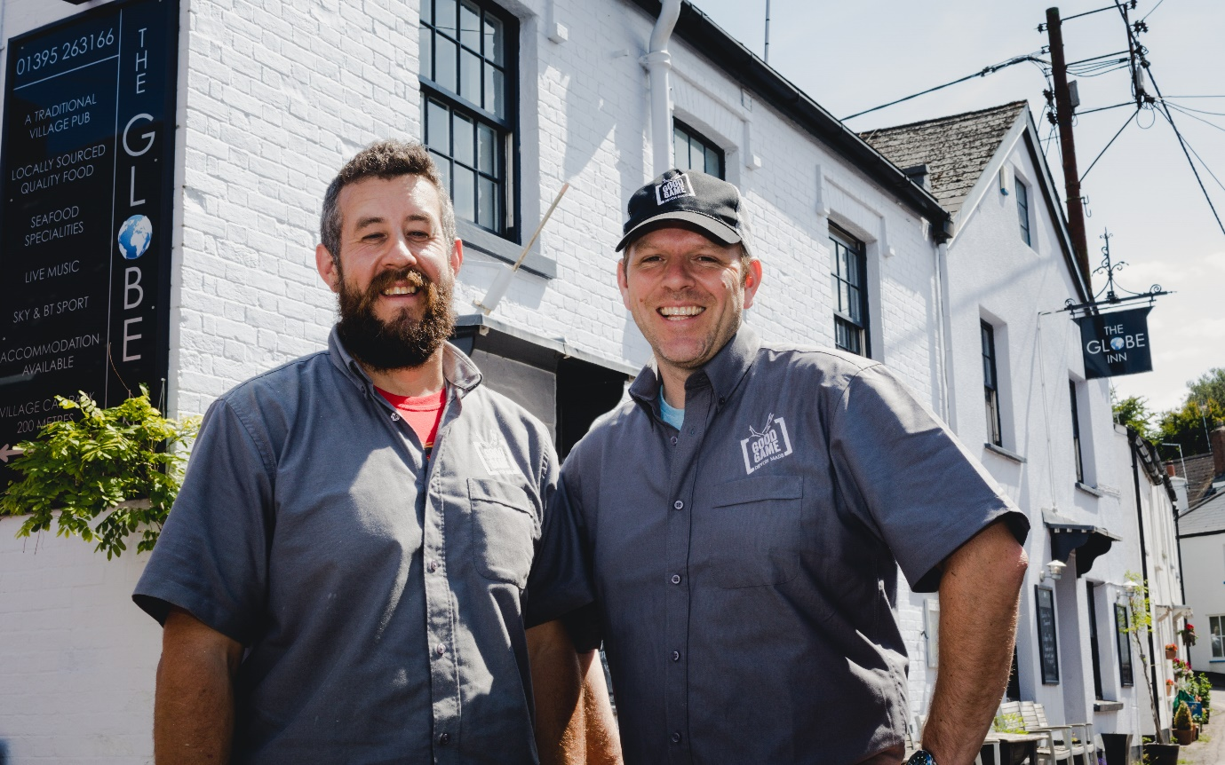

The team behind organic charcuterie company, Good Game, and barbecue smokehouse, The Pig and Pallet, have taken over the helm of The Globe Inn – a traditional pub in Lympstone near Exmouth. The popular pub will be ready to launch on Friday 20th July with an assured menu, a fine selection of craft ales, cider and wine, and an atmosphere to encourage muddy dog-walkers, local residents and food aficionados alike.
With pubs closing at a rate of 29 a week across the UK, Steve Williams and Pete Woodham-Kay have bucked the trend, working with Heavitree Brewery to spend four weeks renovating the premise, updating the cellar, electrics and kitchen.
The cellar has been refitted by St Austell Brewery, who are providing a carefully chosen selection of craft beer. The team are also working with an independent UK wine importer with a chalk mine cellar that stores a revered selection of European wines.
Best known for producing naturally dried game and cured meats, as well as running popular beer and smokehouse restaurant The Pig and Pallet in Topsham, Steve and Pete are keen for The Globe Inn to continue operating as a community watering-hole, serving the thirsty needs of locals and visitors alike.
Co-Director Steve Williams said, “As our first Good Game pub, we wanted to launch the sort of place where we would go ourselves. I have been drinking in The Globe Inn for 15 years and it has always has a relaxed atmosphere, with great food and drink. We’ve got a terrific team on-board who are all equally passionate about warm hospitality and service.”
Bringing Good Game’s much-loved approach of food with integrity to the menu, diners can expect a combination of bold flavours, with gutsy mains alongside creative side dishes. Dishes include macaroni cheese, charcuterie platters, venison burgers and handmade pies.
Pete Woodham-Kay said, “Renowned for being a wildlife haven, a fishing destination and for its lively sailing club, the bustling village of Lympstone is set in the most breath-taking location; just a 20-minute train-ride from Exeter down the dramatic Avocet Line. We’re very much looking forward to joining the community and championing the best of the River Exe.”
The Globe Inn is open every day, serving lunch Wednesday to Sunday and dinner Tuesday to Saturday evenings.
See www.globelympstone.co.uk, email info@globelympstone.co.uk or call 01395 263166 for more details.

-ENDS-
The Globe Inn | The Strand, Lympstone, Exmouth, EX8 5EY | 01395 263166
www.globelympstone.co.uk

Please find further photography available to download here: https://www.dropbox.com/sh/sx3bzugvqj72f0w/AADJVkyUz5KX4cb9hdcRWKo1a?dl=0

For further information, photography or an interview with Steve Williams or Pete Woodham-Kay,
please contact:
Harry Wild at Go Wild Communications – harry@gowildcommunications.com
Mobile: 07540399025; Twitter: @HarryCornwall
Good Game
- Good Game produces: traditional ham, bacon, pancetta, venison salami, rabbit salami, wild boar salami, coppa ham, lomo, cullatello, chorizo, spicy Italian sausage, nduja, pastrami, salt beef, pate, terrine, mortadella and frankfurters. Many of these products have won a Taste of the West Gold award.
- Good Game are a proud biltong supplier to the England RFU.
- All products are made by hand, cured with salt and natural air. They are 100% free of nitrates, saltpetre, additives and do not utilise commercial drying chambers.
- Pigs are slowly reared native breeds. All game is shot wild. Beef is Devon Red Ruby beef from Topsham pastures.

Pig & Pallet
The Pig & Pallet is Good Game’s award-winning restaurant based in Topsham. They cure, butcher, smoke and cook their own hand-reared meats, serving seasonal and hearty dishes along with their vast craft beer selection.

