LYMPSTONE LIVES

MEMORIES OF LYMPSTONE - By Alan Child

When I were a lad (many years ago) for a couple of weeks during the months of June and July the sweet aroma of new mown hay wafted through the village. It was ‘Hay Making time’. The time when the local farmers harvested the lush summer grass in their fields for storage for winter fodder for their cattle.
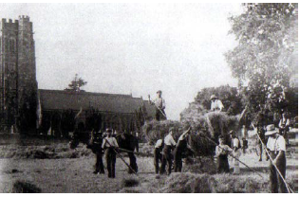

Left: Haymaking in Lympstone with the Parish Church in the background

Firstly, the long grass was cut and left in the fields to dry. To ensure it was dry enough for storage it had to be turned over daily with pitchforks. When sufficiently dry it was manually raked into rows for transfer into large heaps by a contraption called a Sweep (A large wooden rake which was towed by a tractor or lorry) These hay piles were then transported to a dutch barn or hay rick where the dried grass was stored for winter fodder.
Each farmer had their own crew, but I always worked for George Morrish of Underhill Farm alongside my father, George and Lambert Cann and Sam Eyres and of course George himself. Hard but enjoyable work but at the end of each day we were rewarded with a few jars of scrumpy in the cider shed.
Sadly, these days are gone for ever. There are no longer any cattle farms in the Village, any grass that is stored is either baled or turned into silage and many of the hay fields have been developed for housing and are now concrete and tarmac. I feel very lucky and privileged to have enjoyed this wonderful part of Lympstone life.

