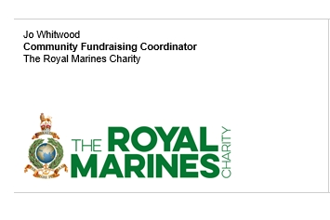

DONATION TO THE ROYAL MARINES CHARITY

It was wonderful to receive the funds raised from Remembrance Day totalling £60.00 to The Royal Marines Charity. It is through such acts of kindness and generosity that the charity is able to continue its work supporting our Royal Marines and their families through life.

The Royal Marines Charity are uniquely placed to understand, respond and react, enabling Marines and their families to overcome their challenges including life changing injury, life limiting illness, mental disability, transition to civilian life and even poverty. Below are just two of the comments from people we have helped along the way.

“I am really lost for words with the support the charity have shown my family, thank you just isn't enough. Nothing I could write would ever be enough to explain how grateful, honoured and humbled I am and forever will be. The charity has given us a life to look forward to, rather than one that brings nightmares.”

“The Royal Marines Charity have gone above and beyond to help me with my transition into the civilian world. Even with a unique and challenging situation the team made it possible for me to achieve everything I needed to kick start my new career. Never be ashamed of asking for help when you need it, and when you do, be sure to talk to the charity.”

As you can see the welcome boost to our funds provided by your kindness is very valuable and we thank you for your support, these funds are very much appreciated and will be put to the best use supporting the Royal Marines Family. If you are interested in other ways to support the charity, please visit www.theroyalmarinescharity.org.uk.

Thank you again
Jo

