Happy to Chat Benches – Lympstone
The `Happy to Chat` Bench
There is clear evidence that loneliness is a major factor today in the UK, not only in the elderly, but equally with younger people as well. It has a major impact on people’s physical and mental health.
Loneliness can be caused by:
- Change in people’s circumstances, loss of network of friends, difficulty communicating, sight & hearing. There are many more reasons that cause this major issue for people.
- In the UK, more than a million older people say they are always, or often feel lonely, according to Age UK.
- Silverline get over 10,500 calls per week with many callers saying to their volunteers that they are the only people that they are likely to talk to that week.
- Whilst there are many groups and societies. There is for many a big hurdle to get over to start with.
It can be difficult making the first contact.
How did “Happy to Chat” benches start?
A lady called Alison Owen-Jones from Cardiff came up with the simple idea following a walk in a Cardiff park, she noted the following:
- For 40 minutes an elderly man sat on a bench in a busy City Centre park, alone. He was ignored by the passing dog walkers, joggers, parents with pushchairs, teenagers with headphones, all too busy to even say "hello".
- Did he want company? Did he want to be alone? Did anyone actually care?
- It was enough to move one woman to try and get strangers to chat, helping inspire a movement that has spread across the UK & the World.
- Wouldn't it be nice if there was a simple way to let people know you're open to a chat, so she came up with the idea of a sign on a bench that would open the avenues for people. She didn't want it to sound too vulnerable so she wrote,
- 'Happy to chat bench. Sit here if you don't mind someone stopping to say hello'.
- "All of a sudden, you're not invisible anymore. “
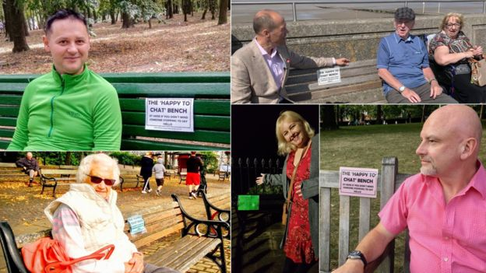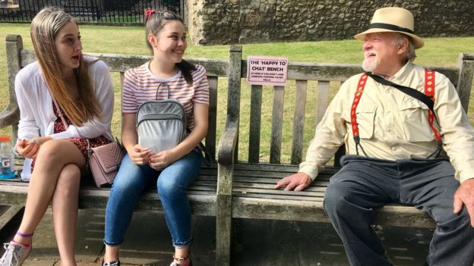
There are already hundreds of them in towns and cities, both in the UK and across some major countries in the world
In Lympstone we could use to start with the following locations, plus Candy’s Field
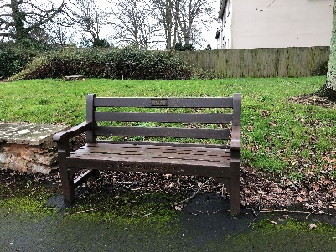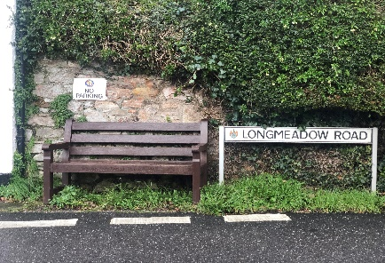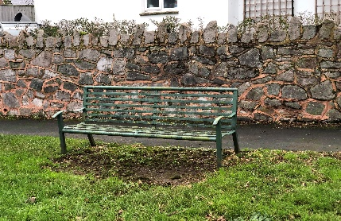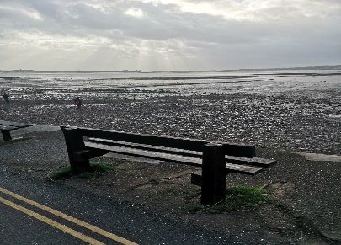
Glebelands Longmeadow Road Highcliffe Sowden End
How do we tell people that these are out there for them?
- Advertise in the Lympstone Herald & The Exmouth Journal. Social Media – Lympstone Facebook pages.
- Local Radio Stations, Posters on the telegraph poles within the village.
- Talks and posters at meetings such as W.I, Playgroups, GP Surgeries, Village Hall, the village pubs, Café, as many locations as we can get. Engage with as many people as we see people in the village about them.
- Ongoing communication to keep them alive. Explore more locations in the Village Parish.

For more information - https://www.bbc.co.uk/news/uk-wales-50000204

