Would you like to help make Lympstone a
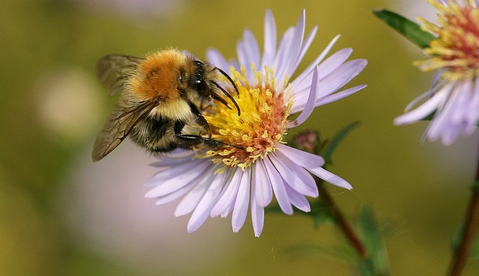
‘Wilder Community’?

In last month’s Lympstone Herald, Mary wrote a letter telling us about Devon Wildlife Trust’s a ‘Wilder Communities’ initiative. She had the wonderful idea to start by collecting your stories about how you’re already engaging with wildlife – whether that’s through your gardening, art, wellbeing appreciation or school education projects.
To make it easier for you to get in touch, we’ve put together a short questionnaire. This will only take a couple of minutes to complete but will help us know who you are and what your interest is. We will not share any personal details without your approval.
You can return this to us either by filling out the hardcopy at the back of this Lympstone Herald and drop into the village shop, or by emailing us the online version you’ll find on the Lympstone village website.
Thank you for getting in touch. We’re really looking forward to hearing from you!
Mary and Rebecca
truell@me.com
rebecca_abrahams@yahoo.com

Wilder Communities Questionnaire
Name
Address
Contact details
(Email/ Mob/ Landline)
Are you already involved with wildlife-friendly activities in Lympstone?
If yes, please tell us a little bit about what you’re up to, and how long you’ve been doing this.
If no, are you interested in becoming more involved?
Are you happy we contact you?

